<https://community.tableau.com/message/713546#713546>

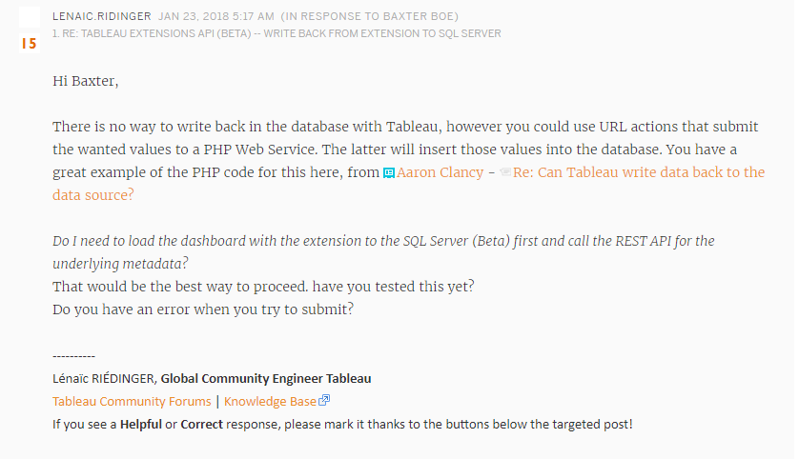https://community.tableau.com/message/224524#224524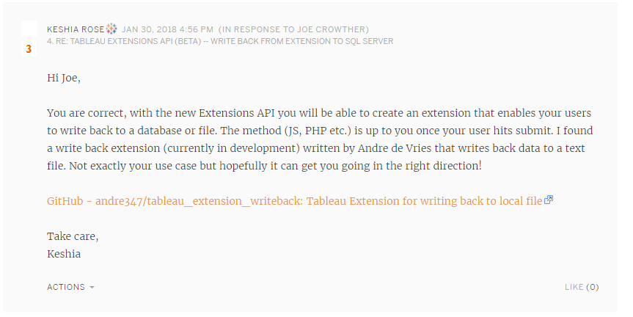

<https://community.powerbi.com/t5/Service/Writeback-functionality/td-p/31>

<http://poweronbi.com/2018/01/write-back-options-in-power-bi/>

